

**E-Project**



Batch Code: PR-201904F



|  |  |
| --- | --- |
| **INDEX** | |
|
|
|
| **1** | **Certificate of Completion** |
| **2** | **Task Statement** |
| **3** | **E-Project Report** |
| **4** | **Acknowledgement** |
| **5** | **Project Synopsis** |
| **6** | **Project Analysis** |
| **7** | **Requirement Specification** |
| **8** | **User Guide** |
| **9** | **Developer Guide And Database** |
| **10** | **Hardware & Software Requirement** |





**CERTIFICATE OF COMPLETION**

### The Certificate is personalized to

**Ameer Hamza**

**Ehtesham Baho**

**The successfully design & developed on Sound**

**E- Project of HDSE (3rd Semester)**

**APTECH Worldwide Computer Education**

**Shahrah-e-Faisal Center, Karachi**





**TASK STATEMENT**

|  |  |  |  |
| --- | --- | --- | --- |
| **Student Id** | **Name** | **Task** | **Status** |
| **1160288** | **Ameer Hamza** | **Complete Website** | **Completed** |
| **1165087** | **Ehtesham Baho** | **Register And Login** | **Completed** |

**E-Project Report**





**ACKNOWLEDGMENT**

**Acknowledgment is not more formality but a genuine opportunity to thank all Those people without that active support in this project would not be able to be Possible We are thankful to almighty ALLAH with his grace and mercy for giving us strength Good sense and confidence to complete the project successfully we presenting on “Rhythm House”. we have tried our best to take all relevant and important topics in consideration so that this project may become more effective and a batter outlook to come. This project has been developed with the help of “PHP / MYSQL / HTML/ CSS/BOOTSTRAP/AJAX/JQUERY” I would like to acknowledge all those who have given moral support and helped me to Make this project a success. I wish to express my gratitude to SIR SHABBIR AHMED For his valuable guidance and support for the completion of this project. And finally.**





**PROJECT SYNOPSIS**

**Background:**

**Rhythm House is a music store that offers not only music but contests and live shows too. They started off with a small shop in collaboration with other reputed companies and then built up their own establishment. They have different stores in other countries at various locations in the city and because of their services they have attracted a vast number of Customers in a very short duration of time. And many more like these.**

**The store aims to break new ground by harnessing the power of technology and revolutionizing processes to make ownership for the customers a truly enjoyable and hassle-free experience. So taking into consideration the expanding business, the company planned to host the primary information via RhythmHouse.com, an Internet Gateway to store dealerships.**



**PROJECT ANALYSIS**

**Requirements Analysis**

Requirements analysis process is an important stage in the system development. It determines the functions of the whole system integrity and stability. Software Requirements analysis is an ongoing process of understanding and progressive Refinement. Through requirements analysis, functions of the Sound system will be Designed as below.

**Requirements**

Music and Videos are the most common source of entertainment today.

SOUND Group wants to host a WEBSITE for Entertainment. Company is looking on hosting new and old Videos and Songs in both REGIONAL and ENGLISH language.

WEBSITE should have proper menu structure and Music and Video should be arranged as per ALBUM, ARTIST, YEAR, GENRE, LANGUAGE etc.

Users should have the option of reviewing and rating the Music and Videos available.

Home Page should have information about the site and a section for latest music and video with 5-5 listings in each.

**Customer Specifications:**

Website will host information about songs and videos with images and description and the “New” image/icon should flash along with the new additions to Music and Videos.

The website will have three users/roles:

1. Administrator
2. USER

The Administrator should be able to do the following:

1. Add Music files with information.
2. Add Video files with information.
3. Create Categories viz. YEAR, ARTIST, ALBUM etc.
4. Delete Music files
5. Delete Video files.
6. Create/Manage Users/Logins
7. Manage information/details on the WEBSITE

The USER should be able to do the following:

1. Register/Create Account [USERID should be unique].
2. Search for MUSIC/Video based on Name, ARTIST, YEAR, ALBUM etc.
3. ADD/Modify Reviews
4. ADD/Modify Rating

**PHP:**

PHP started out as a small open source project that evolved as more and more people found out how useful it was. Rasmus Lerdorf unleashed the first version of PHP way back in 1994.

* PHP is a recursive acronym for "PHP: Hypertext Preprocessor".
* PHP is a server side scripting language that is embedded in HTML. It is used to manage dynamic content, databases, session tracking, even build entire e-commerce sites.
* It is integrated with a number of popular databases, including MySQL, PostgreSQL, Oracle, Sybase, Informix, and Microsoft SQL Server.
* PHP is pleasingly zippy in its execution, especially when compiled as an Apache module on the Unix side. The MySQL server, once started, executes even very complex queries with huge result sets in record-setting time.
* PHP supports a large number of major protocols such as POP3, IMAP, and LDAP. PHP4 added support for Java and distributed object architectures (COM and CORBA), making n-tier development a possibility for the first time.
* PHP is forgiving: PHP language tries to be as forgiving as possible.
* PHP Syntax is C-Like.

**MYSQLI:**

The PHP code consists of a core, with optional extensions to the core functionality. PHP's MySQL-related extensions, such as the MySQLi extension, and the MySQL extension, are implemented using the PHP extension framework. An extension typically exposes an API to the PHP developer, to allow its facilities to be used programmatically. However, some extensions which use the PHP extension framework do not expose an API to the PHP developer.

The PDO MySQL driver extension, for example, does not expose an API to the PHP developer, but provides an interface to the PDO layer above it.

MySQLi is an improved version of the older PHP MySQL driver, offering various benefits.[[1]](https://en.wikipedia.org/wiki/MySQLi#cite_note-overview-1)

The authors of the PHP scripting language recommend using MySQLi when dealing with MySQL server versions 4.1.3 and newer (takes advantage of new functionality)

**JAVA SCRIPT:**

HTML pages are fine for displaying static content, e.g. a simple image or text. However, Most pages nowadays are rarely static. Many of today’s pages have menus, forms, Slideshows and even images that provide user interaction. JavaScript is the language Employed by web developers to provide such interaction. Since JavaScript works with HTML pages, a developer needs to know HTML to harness this scripting language’s full Potential. While there are other languages that can be used for scripting on the Web, in Practice it is essentially all JavaScript.

There are two ways to use JavaScript in an HTML file. The first one involves embedding All The JavaScript code in the HTML code, while the second method makes use of a Separate JavaScript file that’s called from within a Script element, i.e., enclosed by Script tags. JavaScript files are identified by the .js extension. Although JavaScript is Mostly used to interact with HTML objects, it can also be made to interact with other Non-HTML objects such as browser plugins, CSS (Cascading Style Sheets) properties,

The current date, or the browser itself. To write JavaScript code, all you need is a basic Text editor like Notepad in Windows, Gimp in Linux, or BBEdit. Some text editors, like BBEdit feature syntax highlighting for JavaScript. This will allow you easily identify Elements of JavaScript code. The latest versions of Internet Explorer, Firefox, and Opera all support JavaScript.

**JQUERY:**

JQuery is a concise and fast JavaScript library that can be used to simplify event Handling, HTML document traversing, Ajax interactions and animation for speedy Website development. JQuery simplifies the HTML's client-side scripting, thus simplifying

Web 2.0 applications development.

JQuery is a free, open-source and dual-licensed library under the GNU General Public License. It is considered one of the favorite JavaScript (JS)libraries available today. As Of 2012, it is used by more than half of the Web's top sites. JQuery also offers functionality that allows developers to build plug-ins, in addition to the

JavaScript library. This allows for the development of abstractions for animation and Low-level interaction, sophisticated effects and theme able, high-level widgets. The Modular mechanism of the jQuery library facilitates the development of highly effective, Potent Web applications and Web pages. The jQuery library provides several user friendly strategies and functions for rich Application development. Because the functions of jQuery are simple, it is very popular Among developers. JQuery may be used in all Web based applications, in spite of the Technology. It may be used with ASP, PHP, JSP, CGI, Servlets and most Web Programming languages.

**Requirement Specification**

**The Website is to be created based on the following requirements:**

WEBSITE should have proper menu structure and Music and Video should be arranged as per ALBUM, ARTIST, YEAR, GENRE, LANGUAGE etc.

Users should have the option of reviewing and rating the Music and Videos available.

Home Page should have information about the site and a section for latest music and video with 5-5 listings in each.

**Customer Specifications:**

Website will host information about songs and videos with images and description and “New” image/icon should flash along with the new additions to Music and Videos.

The website will have three users/roles:

1. Administrator
2. USER

The Administrator should be able to do the following:

1. Add Music files with information.
2. Add Video files with information.
3. Create Categories viz. YEAR, ARTIST, ALBUM etc.
4. Delete Music files
5. Delete Video files.
6. Create/Manage Users/Logins
7. Manage information/details on the WEBSITE

The USER should be able to do the following:

1. Register/Create Account [USERID should be unique].
2. Search for MUSIC/Video based on Name, ARTIST, YEAR, ALBUM etc.
3. ADD/Modify Reviews
4. ADD/Modify Ratings

Note: Name, Address, Phone Numbers, Email-ids should be mandatory to be provided. Proper Validations should be applied on all Data Fields.

**Solution…**

* **WEBSITE should have proper menu structure and Music and Video should be arranged as per ALBUM, ARTIST, YEAR, GENRE, LANGUAGE etc.**

**------------------**

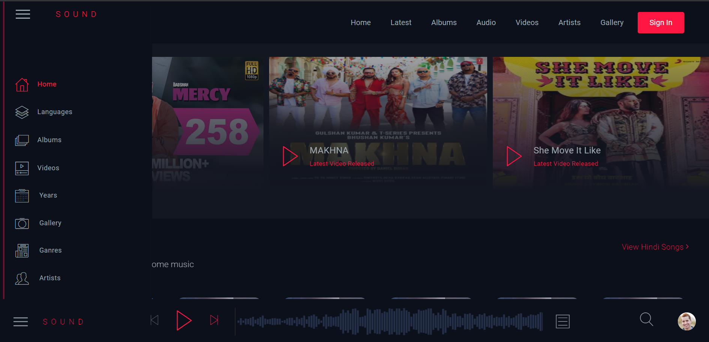

* **Users should have the option of reviewing and rating the Music and Videos available.**

**------------------**

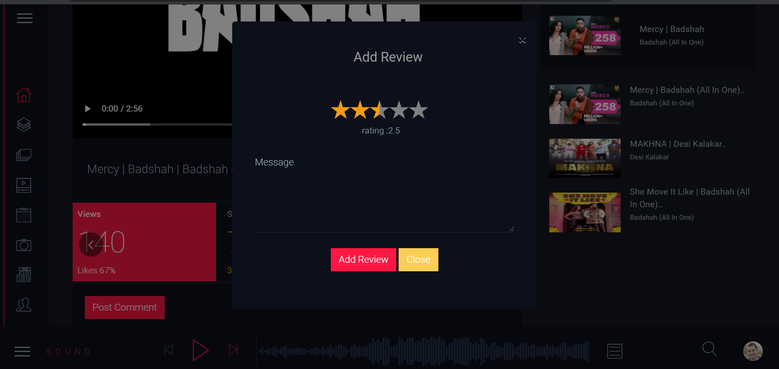

* **Home Page should have information about the site and a section for latest music and video with 5-5 listing in each.**

**------------------**

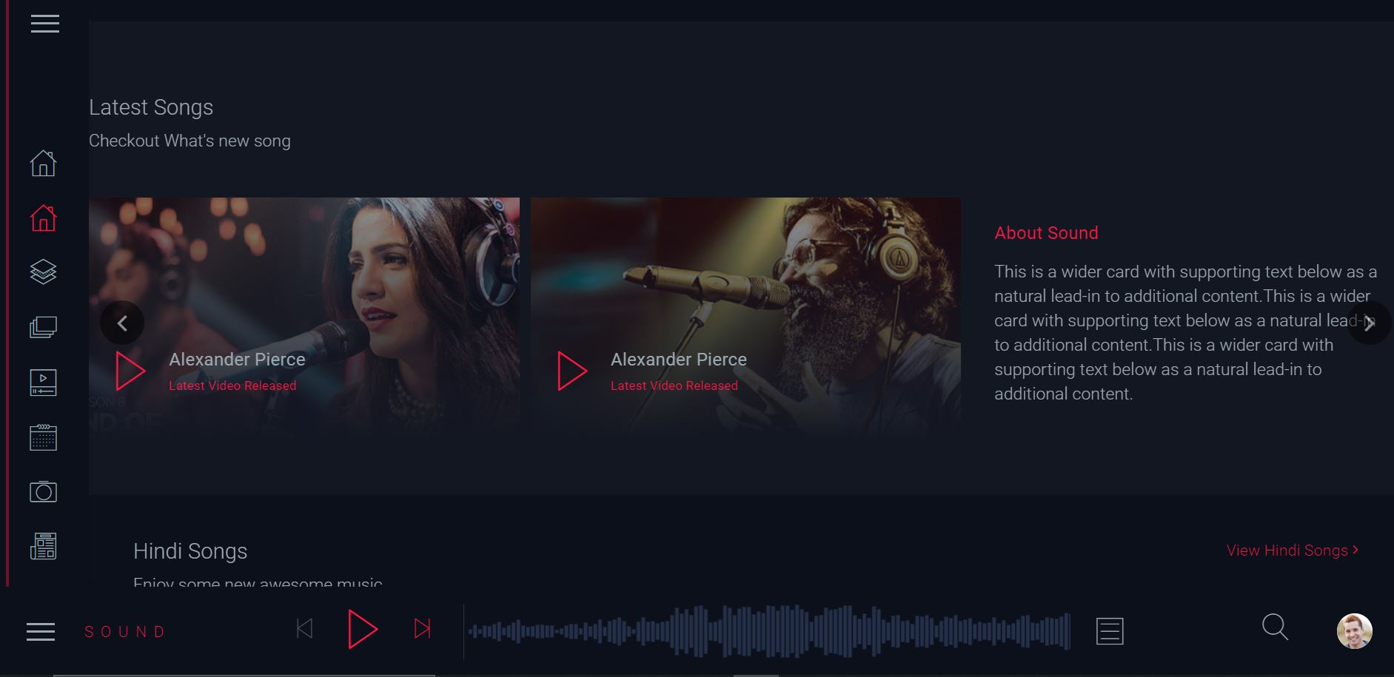



* **Customer Specifications:**
* **Website will host information about songs and videos with images and description and “New” image/icon should flash along with the new additions to Music and Video’s.**

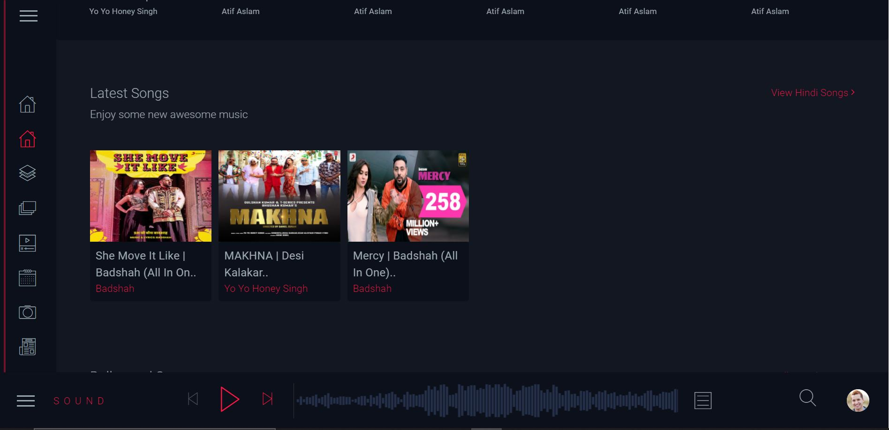

* **The website will have three users/roles:**

1. **Administrator**
2. **USER**

**Administrator Panel/Dashboard**

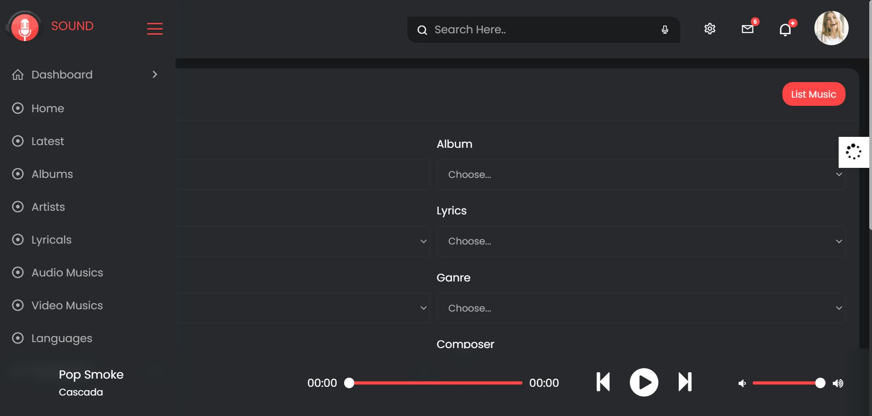

**The Administrator should be able to do the following:**

1. **Add Music files with information.**

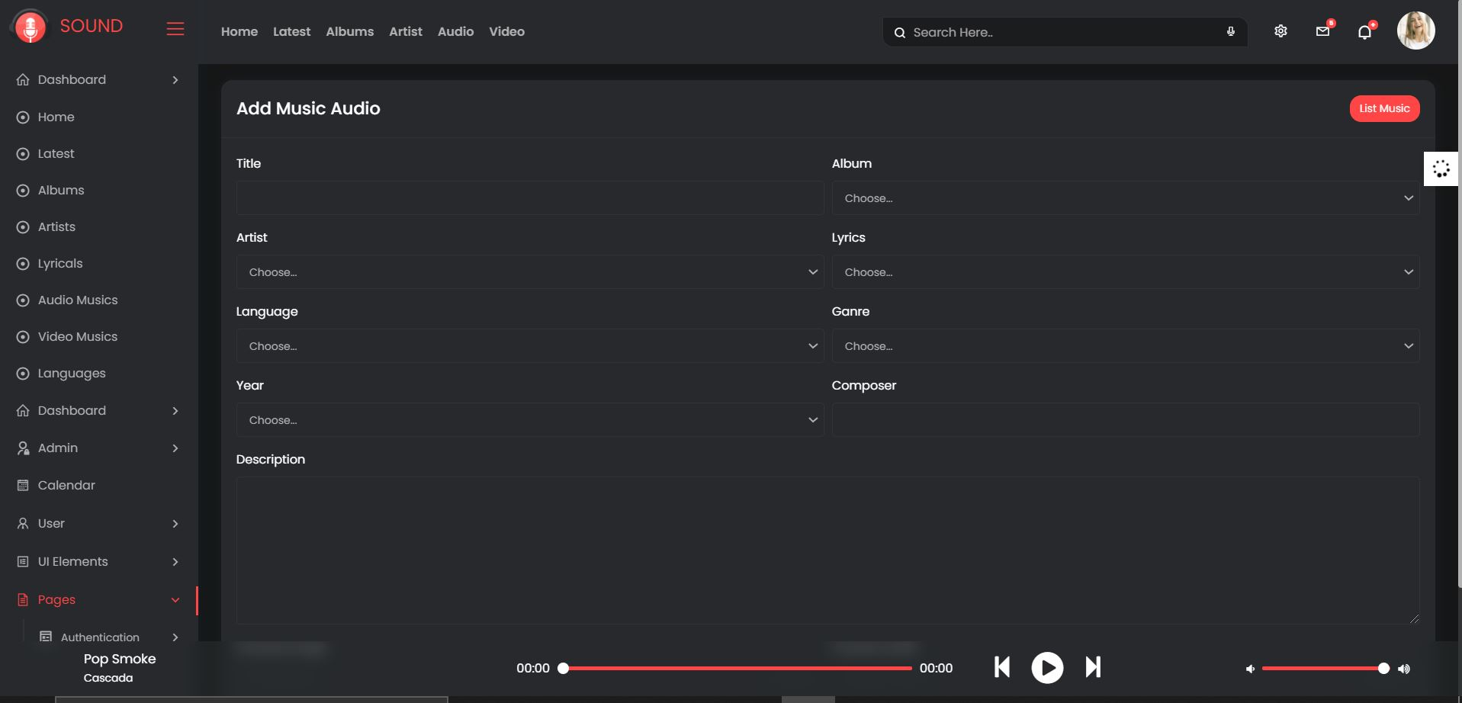

1. **Add Video files with information.**

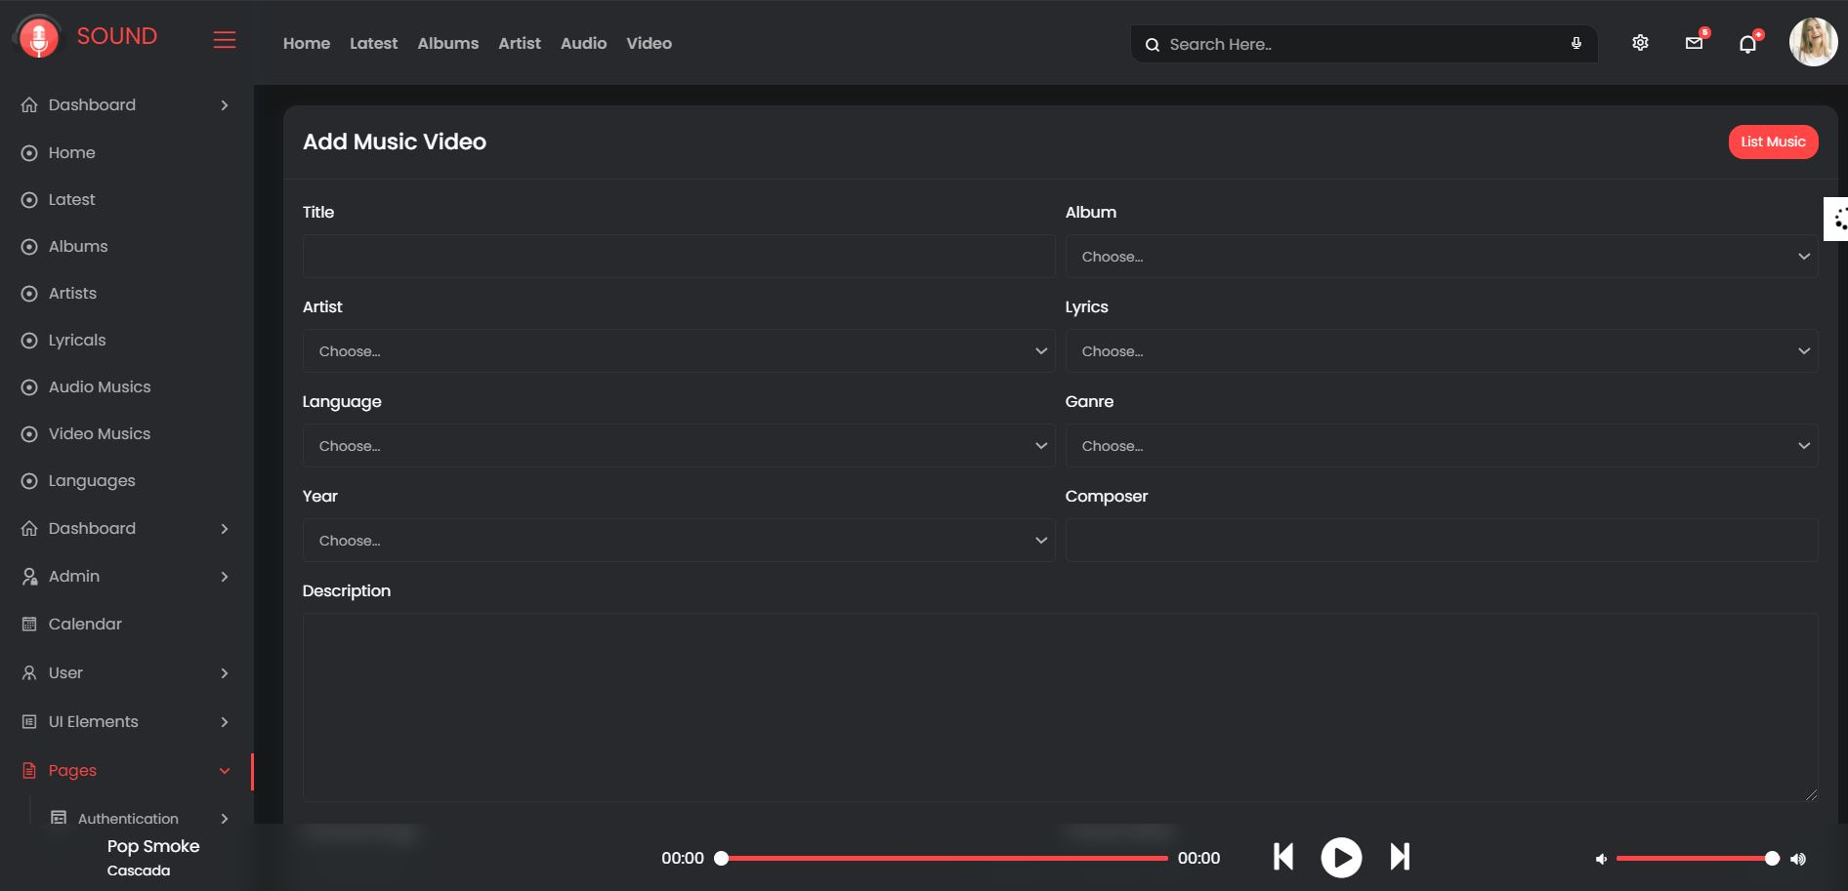

1. **Create Categories viz. YEAR, ARTIST, ALBUM etc.**

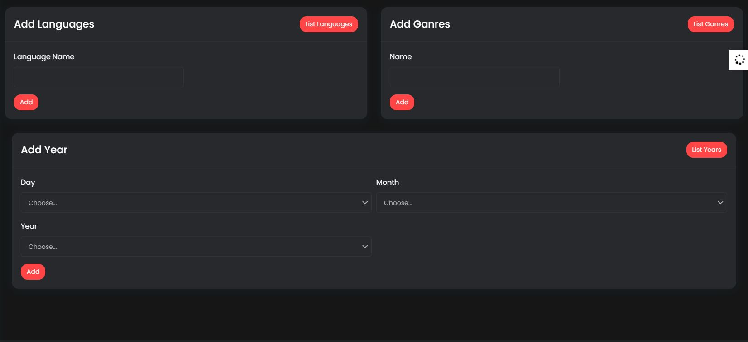

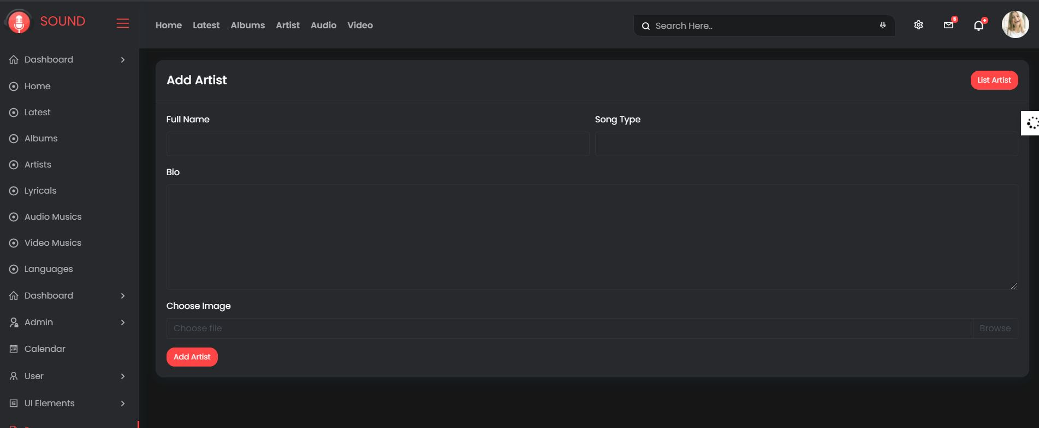

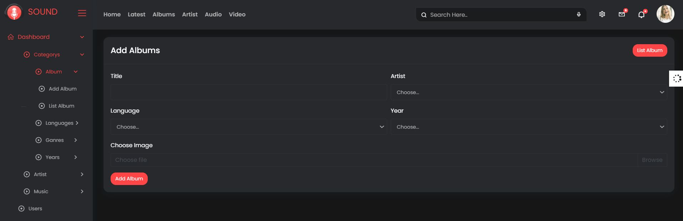

1. **Delete Music files**

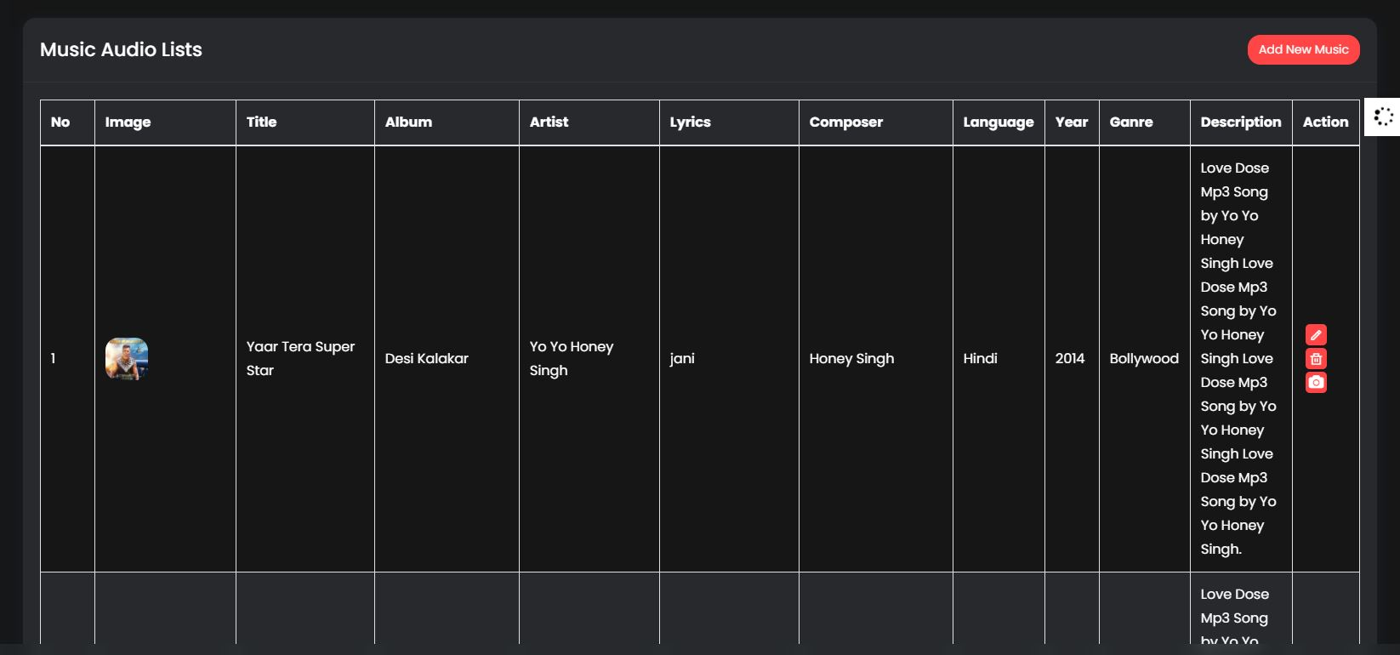

1. **Delete Video files.**

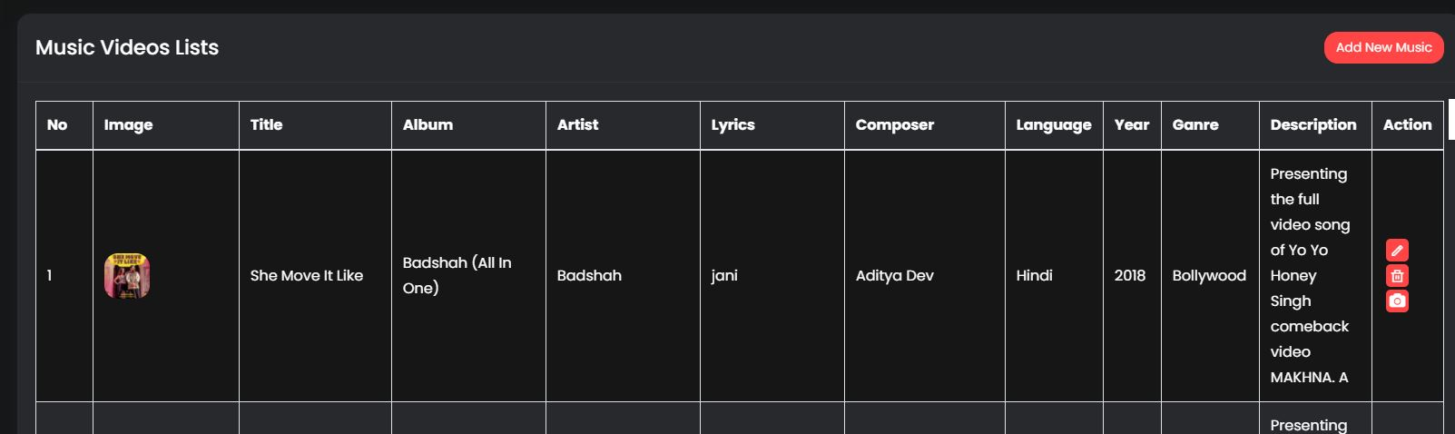

1. **Create/Manage Users/Logins**

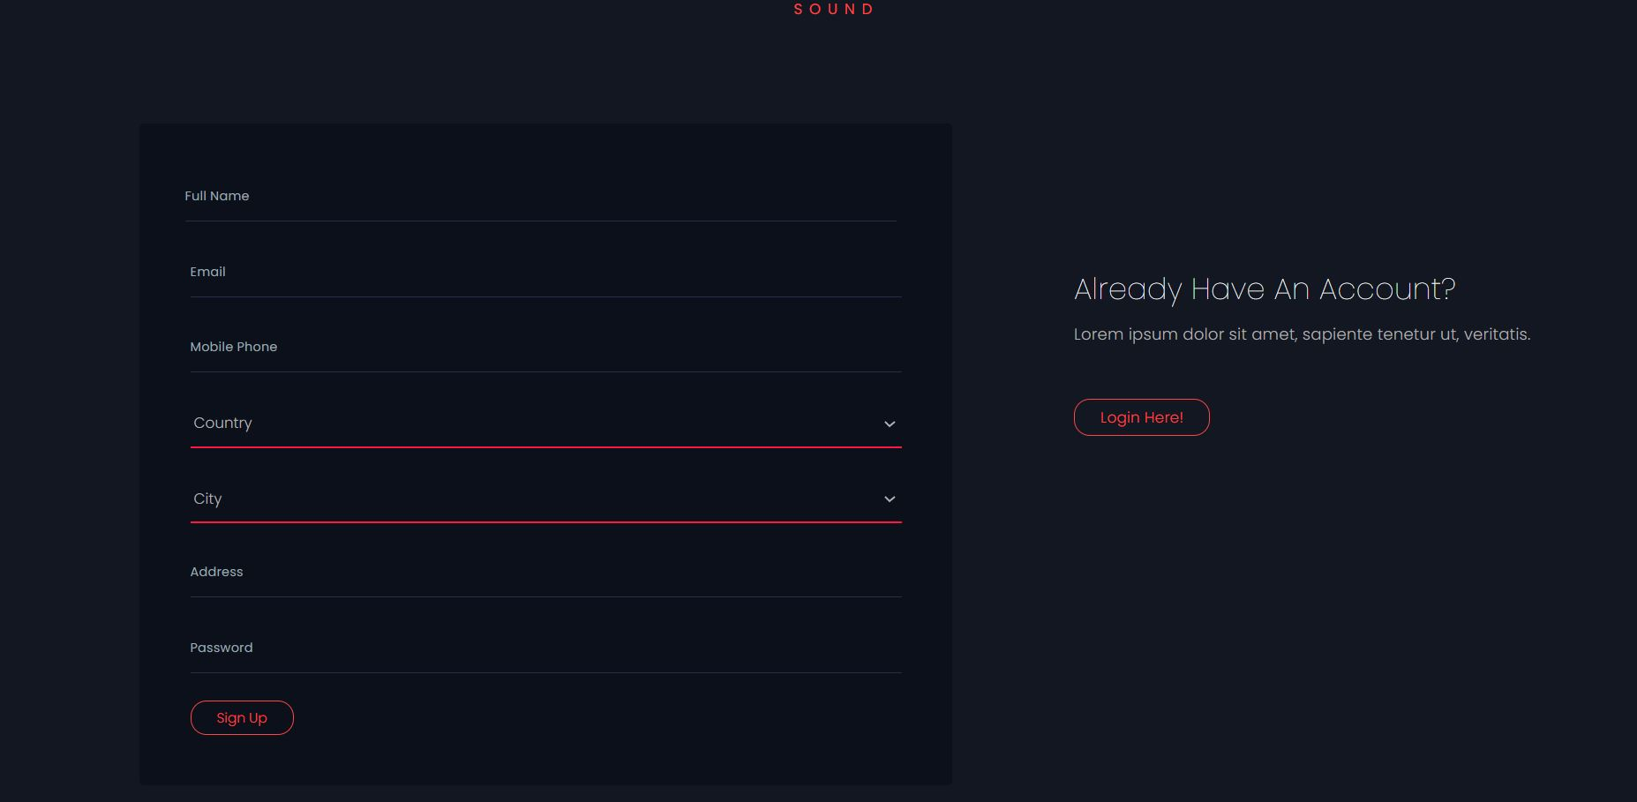

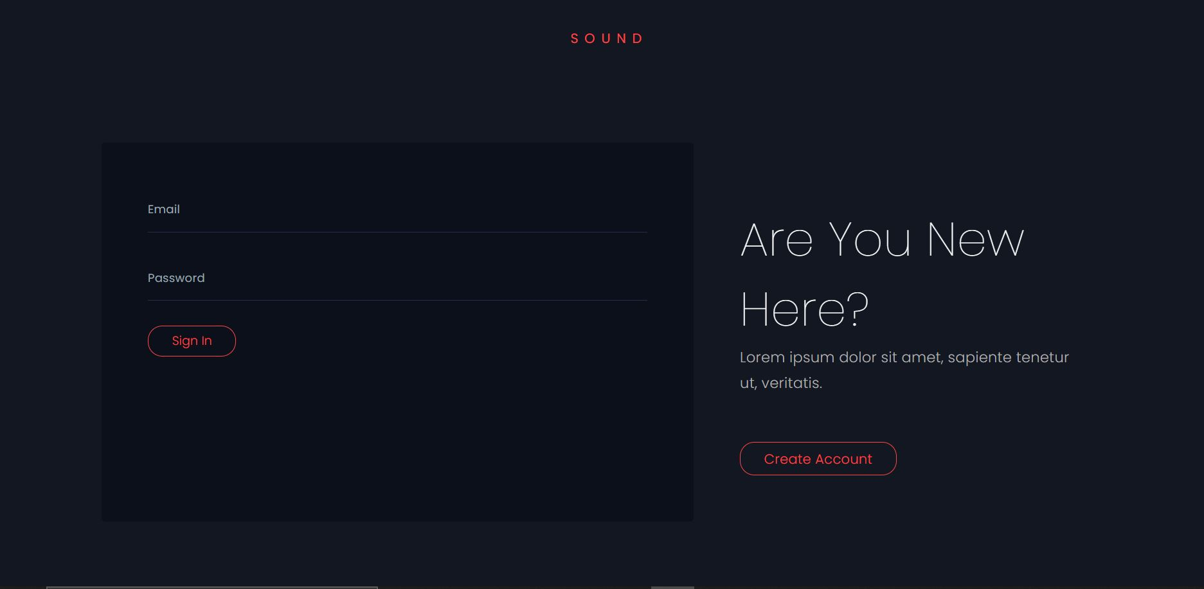

1. **Manage information/details on the WEBSITE**

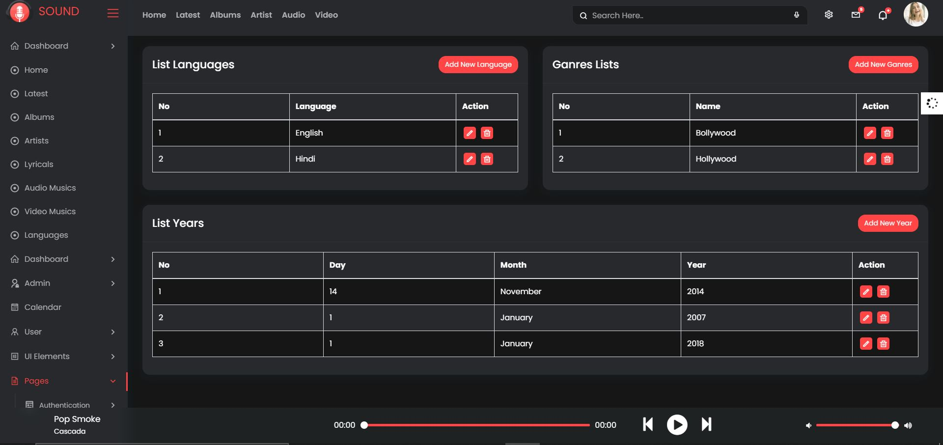

**The USER should be able to do the following:**

1. **Register/Create Account [USERID should be unique].**



**User ID Unique:**

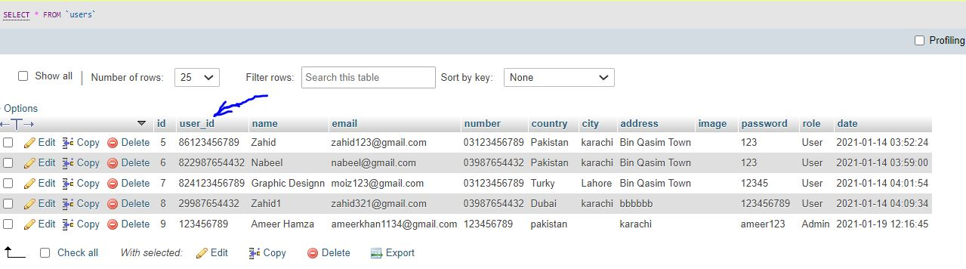

1. **Search for MUSIC/Video based on Name, ARTIST, YEAR, ALBUM etc.**

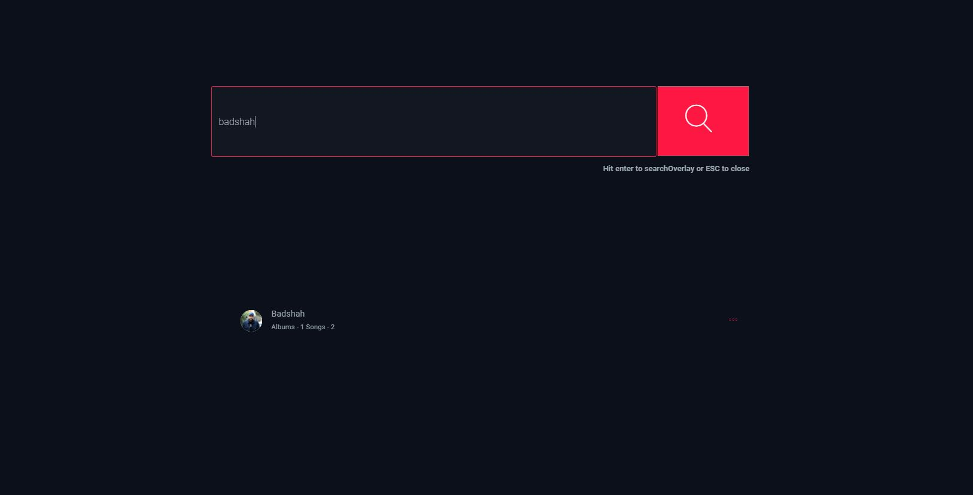

1. **ADD/Modify Reviews**

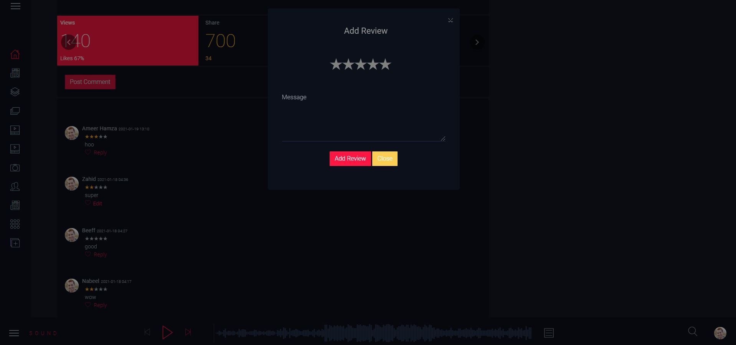

1. **ADD/Modify Ratings**

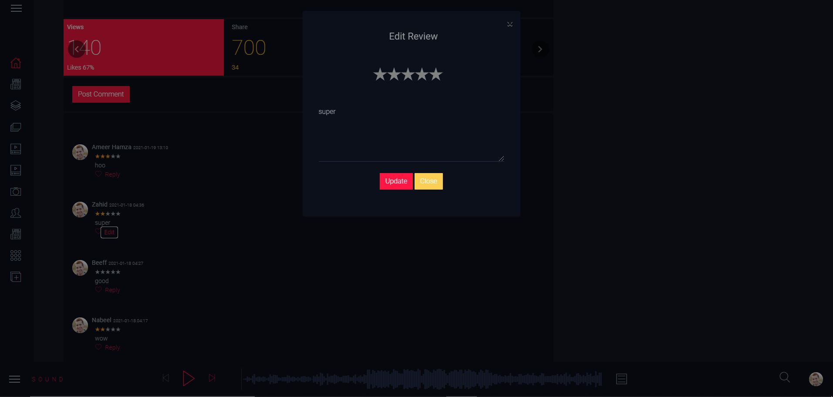

**Note: Name, Address, Phone Numbers, Email-ids should be mandatory to be provided. Proper Validations should be applied on all Data Fields.**

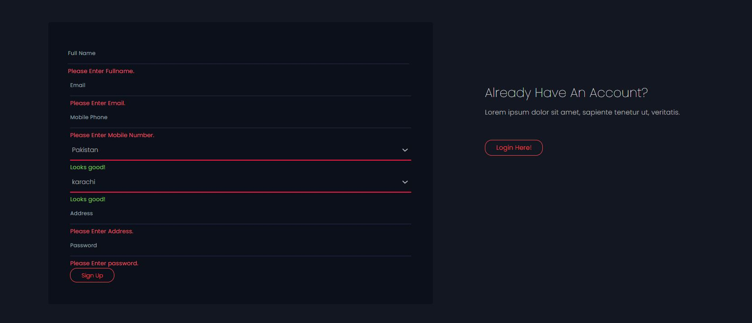





**HTML:**

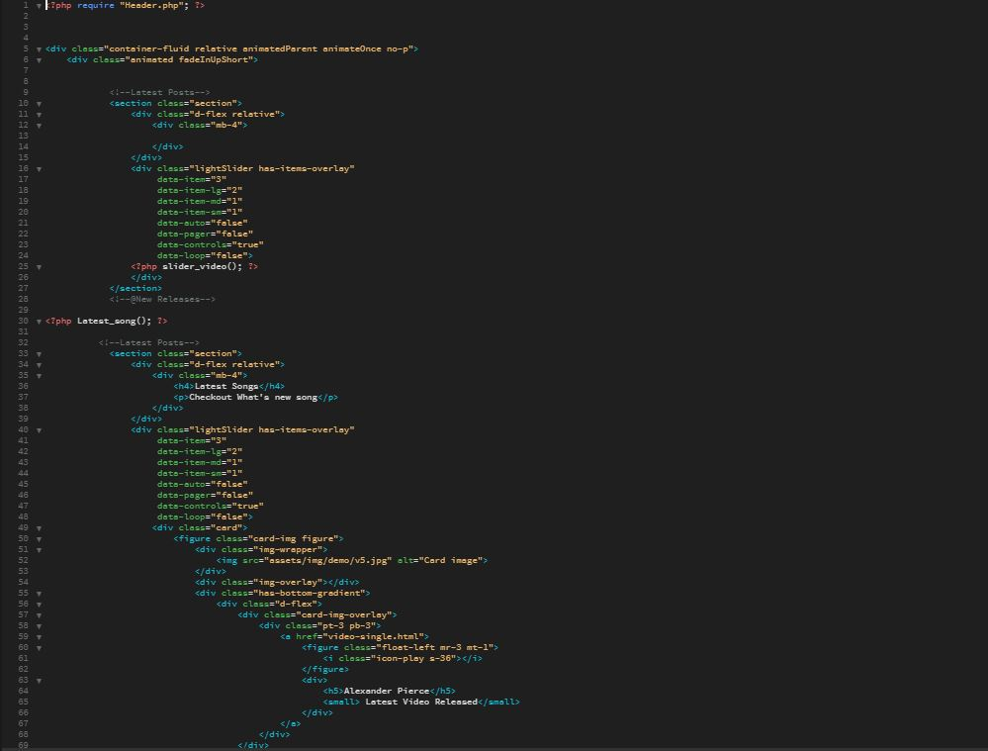

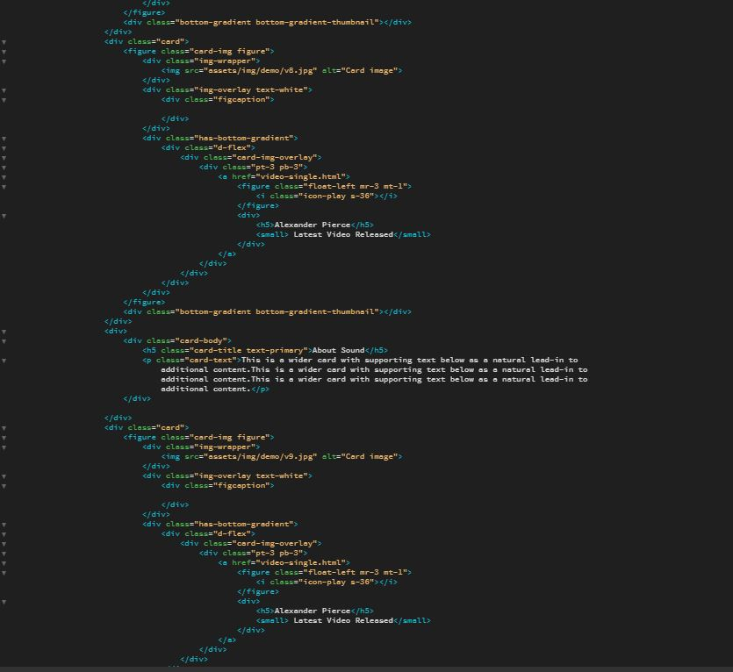



**PHP:**

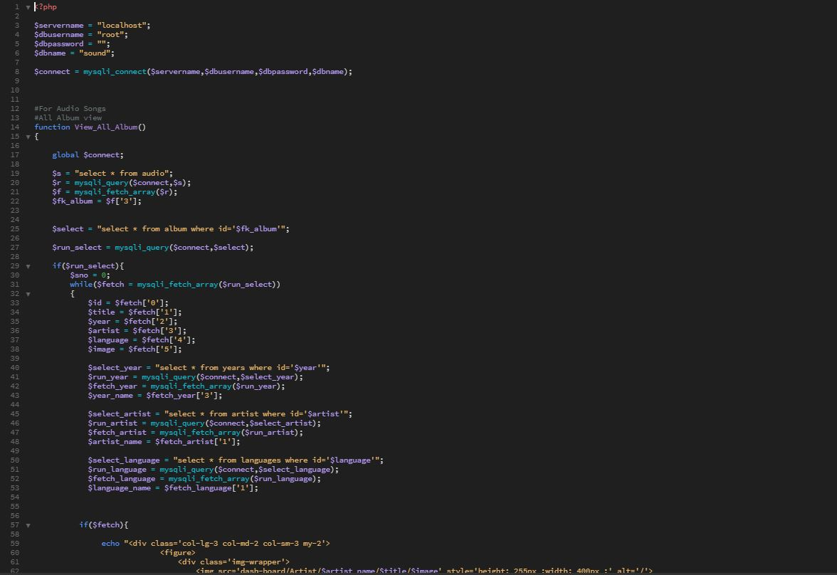

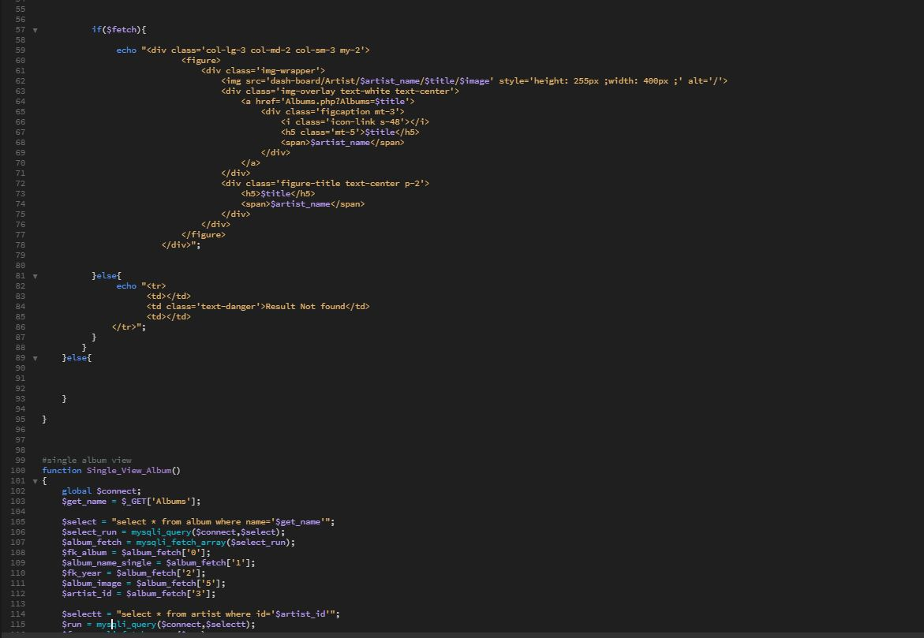



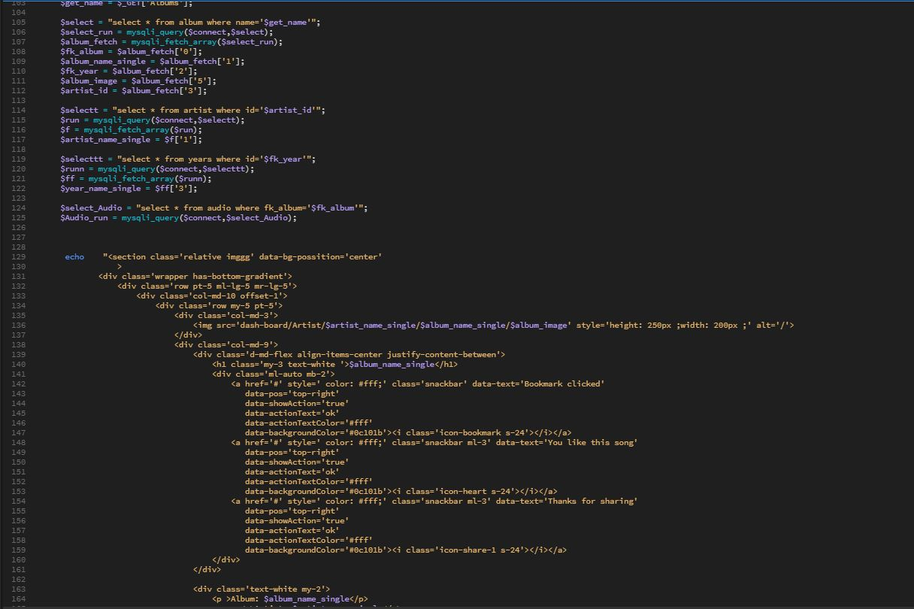

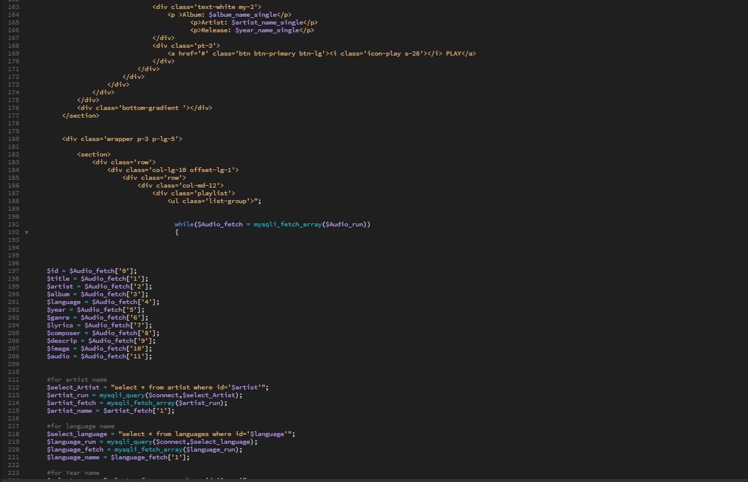

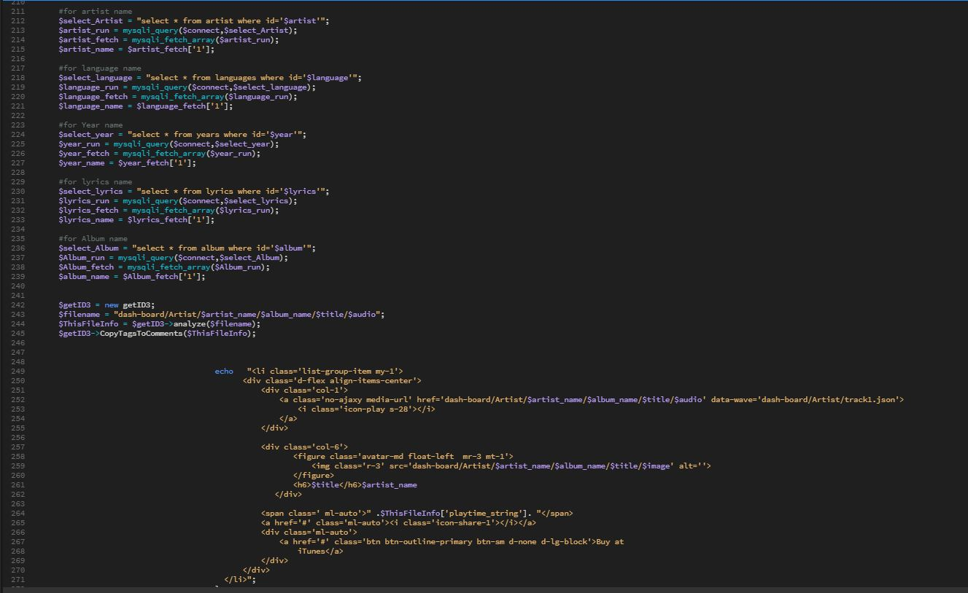

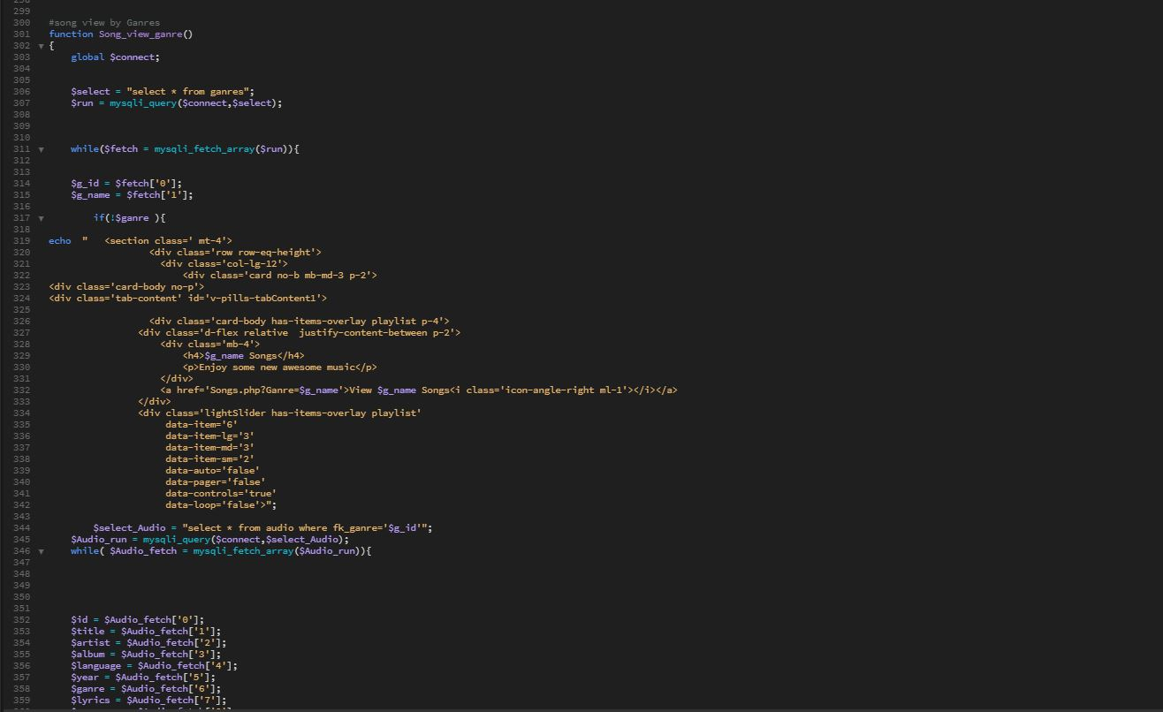

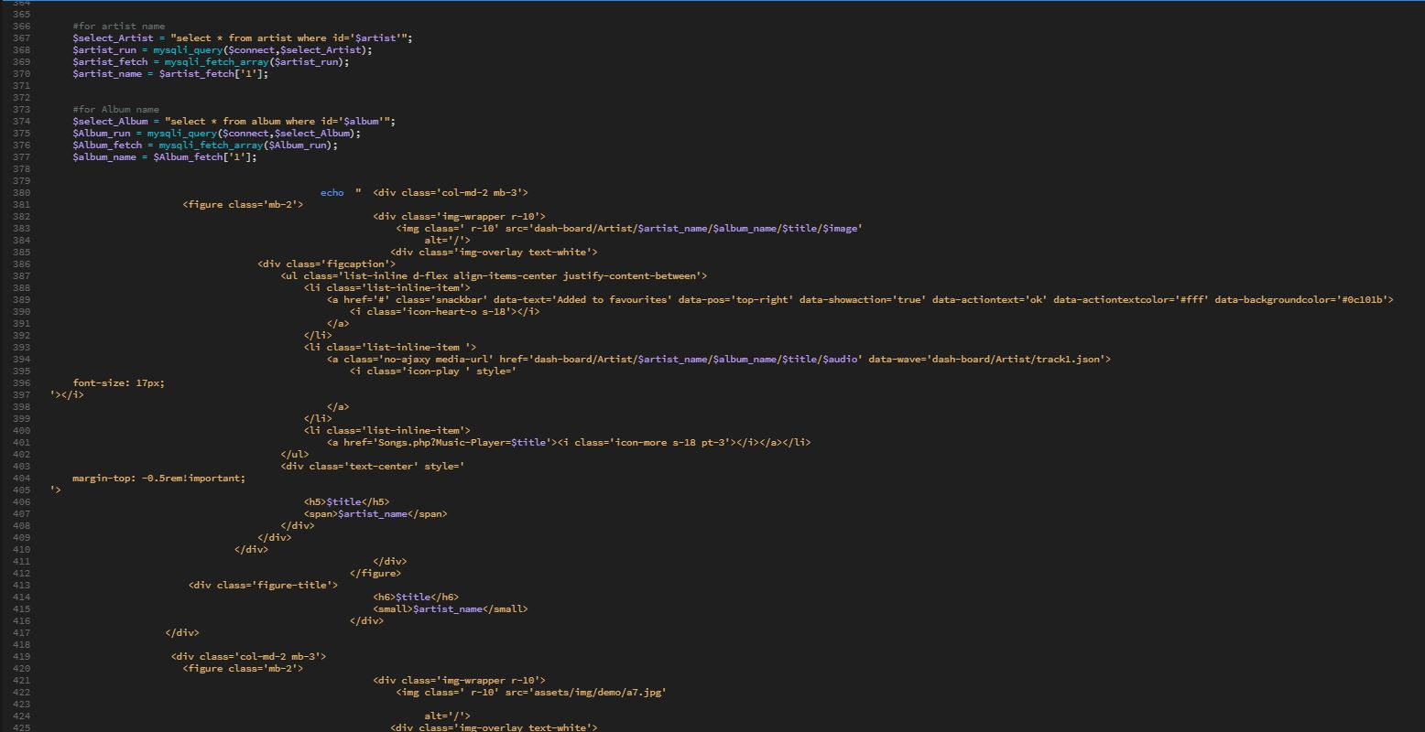

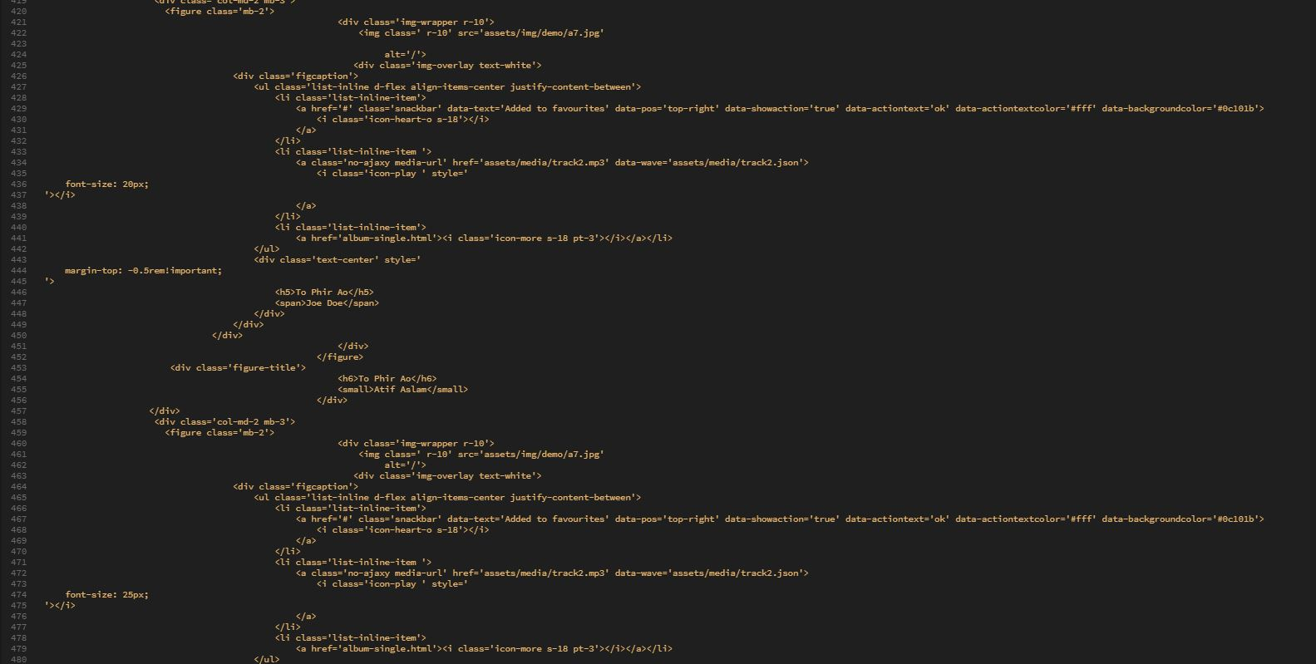

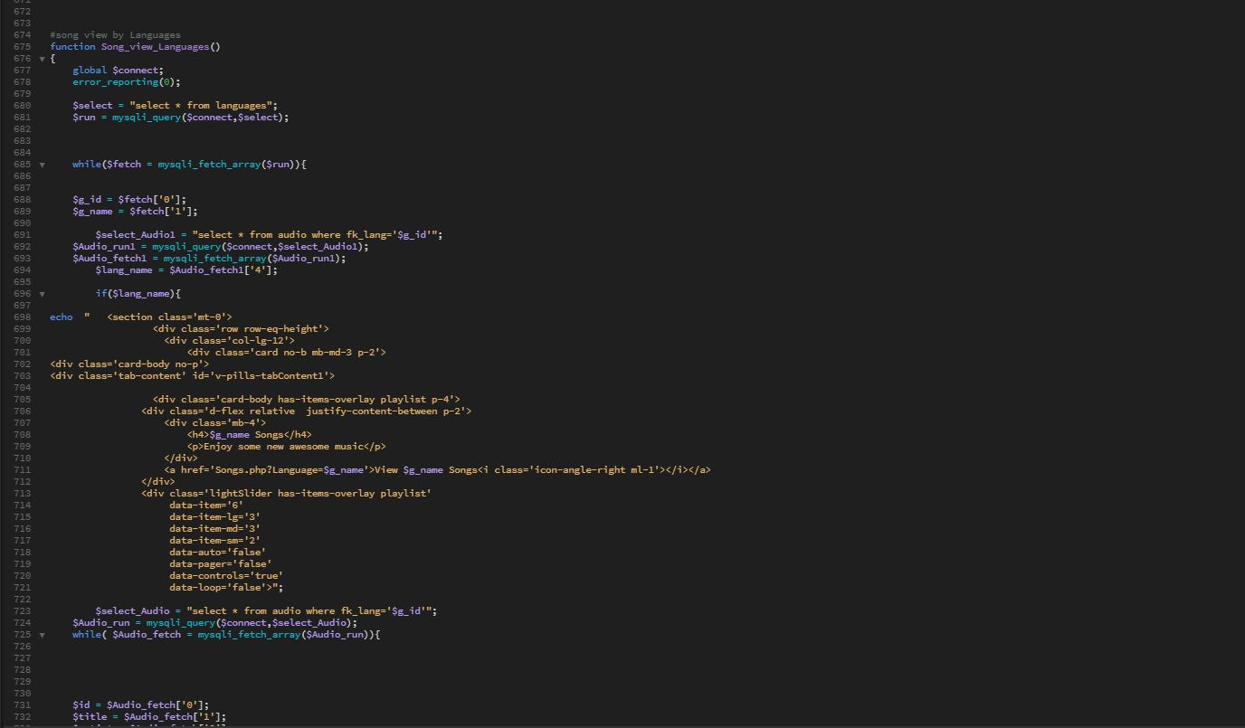

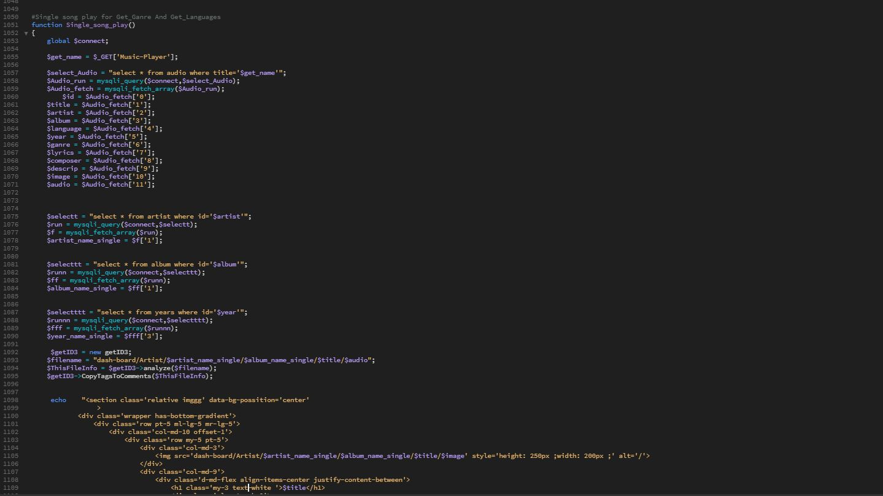

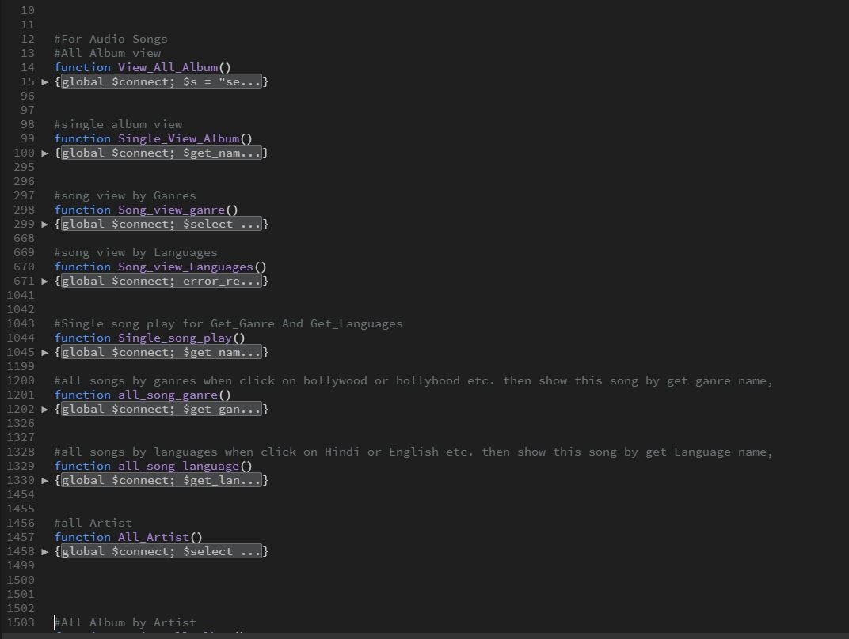

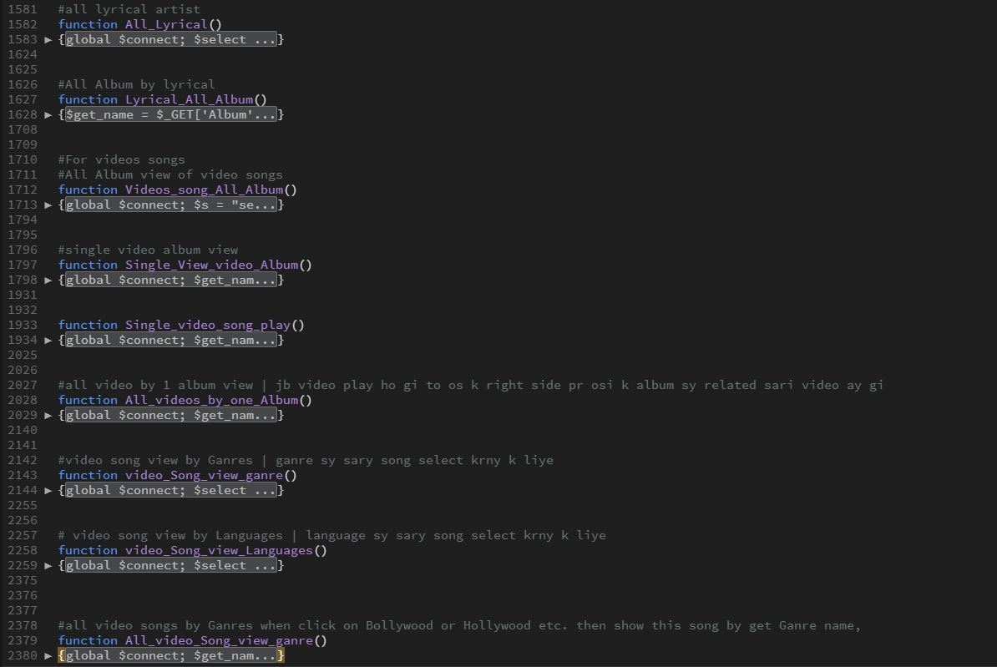

**DATABASE:**

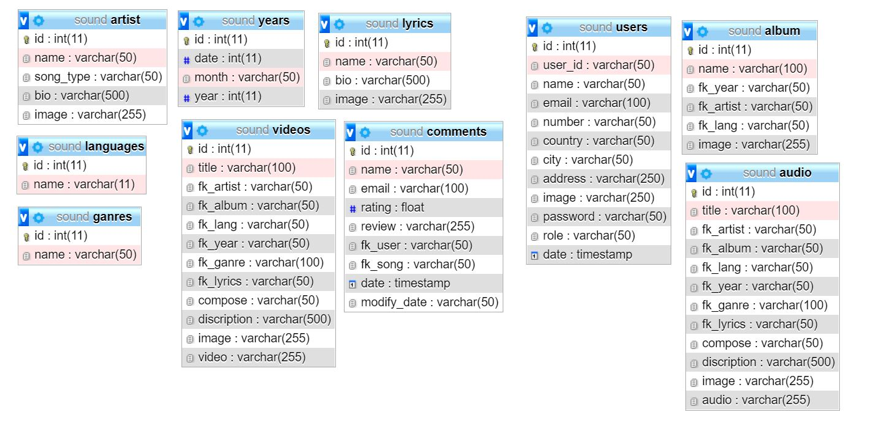

**Hardware/ Software Requirements**

**Hardware**

* A minimum computer system that will help you access all the tools in the courses is a Pentium 166 or better
* 128 Megabytes of RAM or better

**Operating System**

* Windows Server

**Software**

* PHP
* MySQL
* Dreamweaver



**THANK YOU**